Warehouse Inventory and Reorder System

NAME:APARNA
ROLL NO : 2620030367
1. Abstract
The Warehouse Inventory and Reorder System is a Java project used to manage product stock in a warehouse. It stores product details like ID, name, price, quantity, and reorder level using arrays. The system displays product details, calculates total stock value, and gives a reorder warning when the quantity is low. It also allows the user to sell a product and updates the remaining stock.
2. Advantages and Disadvantages
Advantages
- Easy to use and understand.
- Stores product details using arrays.
- Calculates total stock value automatically.
- Gives a warning when stock is low.
- Updates the quantity after a sale.
Disadvantages
- Can store only 5 products.
- Data is lost when the program is closed.
- It is a console-based system.
- Has limited features.
3. Implementation Details AND Algorithm
Implementation Details
The project is developed using Java and uses the Scanner class for input. Arrays are used to store product ID, name, price, quantity, and reorder level. The program uses for loops and if-else statements to display products, check stock, calculate total value, and handle product sales.
3.1 Technologies Used
- Programming Language: Java
- Input: Scanner class
- Data Storage: Arrays
- IDE: Eclipse
- Concepts Used: Loops, if-else statements, variables, operators, and arrays
- 3.2 Algorithm

- Step 1: Start the program.
- Step 2: Create a Scanner object and arrays for product details.
- Step 3: Enter the details of 5 products.
- Step 4: Store the product details in the respective arrays.
- Step 5: Display the product details and calculate the total value.
- Step 6: Compare the quantity with the reorder level.
- Step 7: Enter the Product ID to sell and search for the product.
- Step 8: Enter the quantity to sell and check the available stock.
- Step 9: Update the quantity after a successful sale.
- Step 10: Display the updated stock and reorder status.
- Step 11: Stop the program.

JAVA CODE
import java.util.Scanner;

public class WarehouseInventory {

public static void main(String[] args) {

Scanner sc = new Scanner(System.in);

String[] productName = new String[5];
int[] productId = new int[5];
double[] price = new double[5];
int[] quantity = new int[5];
int[] reorderLevel = new int[5];

// Enter product details
System.out.println("===== WAREHOUSE INVENTORY SYSTEM =====");

for (int i = 0; i < 5; i++) {

System.out.println("\nEnter details for Product " + (i + 1));

System.out.print("Enter Product ID: ");
productId[i] = sc.nextInt();

sc.nextLine();

System.out.print("Enter Product Name: ");
productName[i] = sc.nextLine();

System.out.print("Enter Price: ");
price[i] = sc.nextDouble();

System.out.print("Enter Quantity: ");
quantity[i] = sc.nextInt();

System.out.print("Enter Reorder Level: ");
reorderLevel[i] = sc.nextInt();
}

// Display products
System.out.println("\n===== PRODUCT DETAILS =====");

for (int i = 0; i < 5; i++) {

System.out.println("\nProduct " + (i + 1));
System.out.println("Product ID: " + productId[i]);
System.out.println("Product Name: " + productName[i]);
System.out.println("Price: ₹" + price[i]);
System.out.println("Quantity: " + quantity[i]);
System.out.println("Reorder Level: " + reorderLevel[i]);

double totalValue = price[i] * quantity[i];

System.out.println("Total Value: ₹" + totalValue);

if (quantity[i] <= reorderLevel[i]) {
System.out.println("Status: REORDER REQUIRED");
} else {
System.out.println("Status: Stock Available");
}
}

// Sell products
System.out.println("\n===== SELL PRODUCT =====");

System.out.print("Enter Product ID to sell: ");
int searchId = sc.nextInt();

boolean found = false;

for (int i = 0; i < 5; i++) {

if (productId[i] == searchId) {

found = true;

System.out.print("Enter quantity to sell: ");
int sold = sc.nextInt();

if (sold <= quantity[i]) {

quantity[i] = quantity[i] - sold;

System.out.println("Sale successful!");
System.out.println("Remaining Quantity: " + quantity[i]);

if (quantity[i] <= reorderLevel[i]) {
System.out.println("WARNING: REORDER REQUIRED!");
} else {
System.out.println("Stock is sufficient.");
}

} else {
System.out.println("Not enough stock available.");
}
}
}

if (found == false) {
System.out.println("Product not found.");
}

sc.close();
}
}
OUTPUT SCREENSHOT
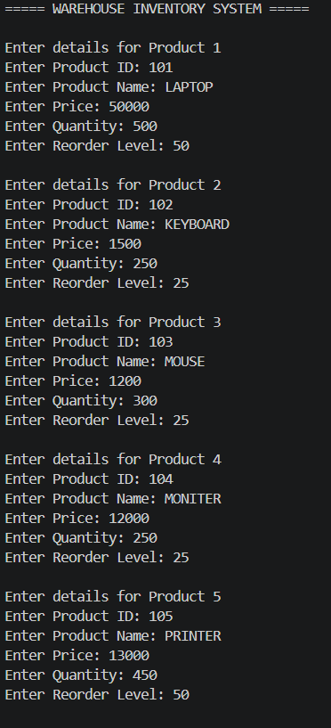
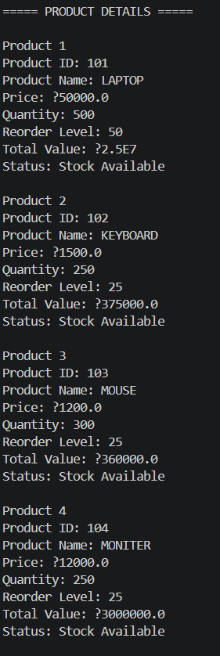
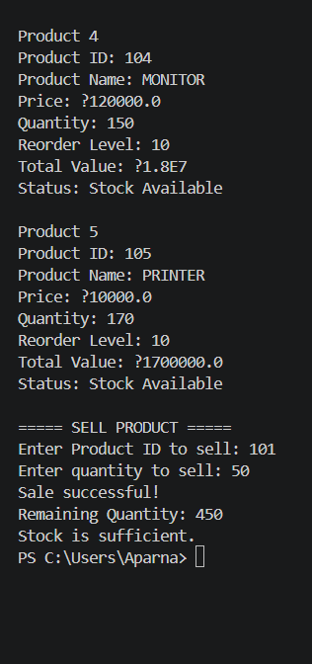

Conclusion and Future Work
Conclusion
The Warehouse Inventory and Reorder System successfully manages basic warehouse stock using Java. The project stores product information such as product ID, name, price, quantity, and reorder level using arrays. It also calculates the total stock value, checks the stock level, displays reorder warnings, and updates the quantity after a product is sold.
This project helped in understanding important Java concepts such as arrays, loops, if-else statements, variables, operators, and the Scanner class. The system is simple, easy to use, and suitable for basic inventory management.
Future Work

In the future, the system can be improved by adding more features, such as:
- Allowing more than 5 products.
- Adding a product search and update option.
- Adding a restock/reorder option.
- Storing data permanently using a file or database.
- Adding a login system for security.
- Generating sales and inventory reports.
- Creating a graphical user interface (GUI) instead of only using the console.

